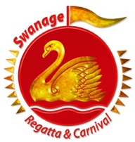
SWANAGE CARNIVAL

Swanage Carnival Procession Entry Form

Sunday July 31st, 2022 @ 3pm

Name………………………………………...Title of Entry………...…………………....

Address……………………………………………………….……………….………….

……………………………………………………………………………………………….

Mobile Telephone No…………………......................................................................

Email Address………………………………………………………………………………

Please Note: This person MUST be on site with the entry on Carnival Day.

The mobile number MUST be a valid contact in case of emergency on Carnival Day

Classes

- Walking : All Entries / Performers on foot in Fancy Dress

B Vehicle Mounted: Trade Tableau, Companies, Commercial

C Vehicle Mounted: Large Tableau over 3.5 Ton, Adults & Children

D Vehicle Mounted: Small Tableau under 3.5 Ton, Adults & Children

Please tick if you have music on your float
Please tick if you are entering Wareham Procession*

FOR VEHICLE MOUNTED ENTRIES ONLY: Approximate size of vehicle

Car or similar Medium Van / Small Lorry Tractor & Trailer /Articulated Lorry

*If you take part in both Swanage & Wareham processions you will be entered for the ‘best in Purbeck’ trophy.
Please see Wareham Carnival website for details of their procession. - www.wareham-carnival.org.uk

You could receive £30 towards your costs if you enter your float before the 17th July, note: this will be only awarded at the discretion of the committee and does not apply to Bands or Dancers.

Please send completed entry form to;
Procession, Unit 8, Jaden Business Park, Prospect Way, Swanage. BH19 1EJ

I have read and agree to abide by the Rules.

Signature: …………………………………………….…

Name Printed………………………………….Date…………

Swanage Regatta and Carnival will hold personal data about you including your name, postal address, phone number(s) and an email address. We will keep your data for a maximum of one year unless there is a specific reason to retain it. Data you have shared with us will not be shared with any external parties without your permission and will only be used to contact you for matters related to this event

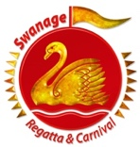
SWANAGE CARNIVAL

ONCE UPON A TIME ….on Carnival Procession Day

Sunday July 31st, 2022 @ 3pm

Please note our Rules, which apply to all participants in the Procession:

The Swanage Regatta & Carnival Committee accepts no responsibility for any loss, damage or injury sustained as a result of participation in this year’s carnival. Entrants are, therefore advised to insure against all risks.

ALL ENTRANTS MUST ARRIVE BY 1.30 pm. Judging will take place shortly after this

On receipt of your entry form we will forward prior to the procession your Class Badge and Lorry Number which must be prominently displayed on the day to assist in parking and judging.

Assembly:

We must advise that due to Health and Safety, we ask that you ensure all scenery on the floats is securely fixed. All floats should be double roped to prevent anyone falling from the float, all children should be seated on the floor and adults should have adequate hand holds if standing. Please ensure that refreshments are available for your group and that children are accompanied at all times.

- Class A is for all walking entries and should assemble on the Sandpit Field.
- Class B, C, D: You will be directed by Marshalls at Northbrook Road to your assembly point.
- All Vehicles must be roadworthy, taxed and insured to participate.
- We ask that you provide 2 Steward’s in Hi-Viz to walk either side of your float
- The maximum size of any single entry is 15 metres in length and 4.8 metres in height.
- Entrants are required to display the Class entered and Lorry Number.
- All entries in the procession must be ready to move at 3pm, No entry will move until directed by the marshals. You may disperse or proceed to your start point to dismantle your float.
- The Committee reserves the right to refuse entries, which, in their opinion may give offence.
- All Judges and Committee decisions will be final.
- All trophies awarded should be returned to the organising committee immediately after the judging. This is due to trophies being lost in past years.
- Entrants wishing to collect money en-route will be given an official collecting bucket. It will be collected from you at the end of the Procession.
- THROWING OR SQUIRTING OF WATER OR OTHER LIQUID IS FORBIDDEN.
- PLEASE REMEMBER THAT MONEY COLLECTED IS FOR CARNIVAL CHARITIES AND NOT FOR ANY OTHER CAUSE.
- Please be aware that official photographers will be taking photographs of this event for publication on our website and future publications. The photographers will be wearing ID Badges, please advise them if you object to your photo being taken.

REMEMBER You could receive £30 towards your costs if you enter your float before the 17th July, note: this will be only awarded at the discretion of the committee and does not apply to Bands or Dancers.

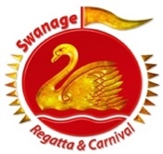
SWANAGE CARNIVAL

INFORMATION FOR ALL PARTICIPANTS IN THIS YEARS PROCESSION

Carnival Procession Theme: ONCE UPON A TIME….…

ALL ENTRANTS MUST ARRIVE BY 1.30 pm. Judging will take place shortly after this

The Categories are:

A ) Walking: All entries / performers on foot (all Ages) – Fancy Dress, Cycles and Prams.

B ) Vehicle Mounted; Trade Tableau – Companies / Commercial.

C ) Vehicle Mounted: Large Tableau – Over 3.5 Ton – Adults and Children.

D ) Vehicle Mounted : Small Tableau –Under 3.5 Ton – Adults and Children

The Procession Route:

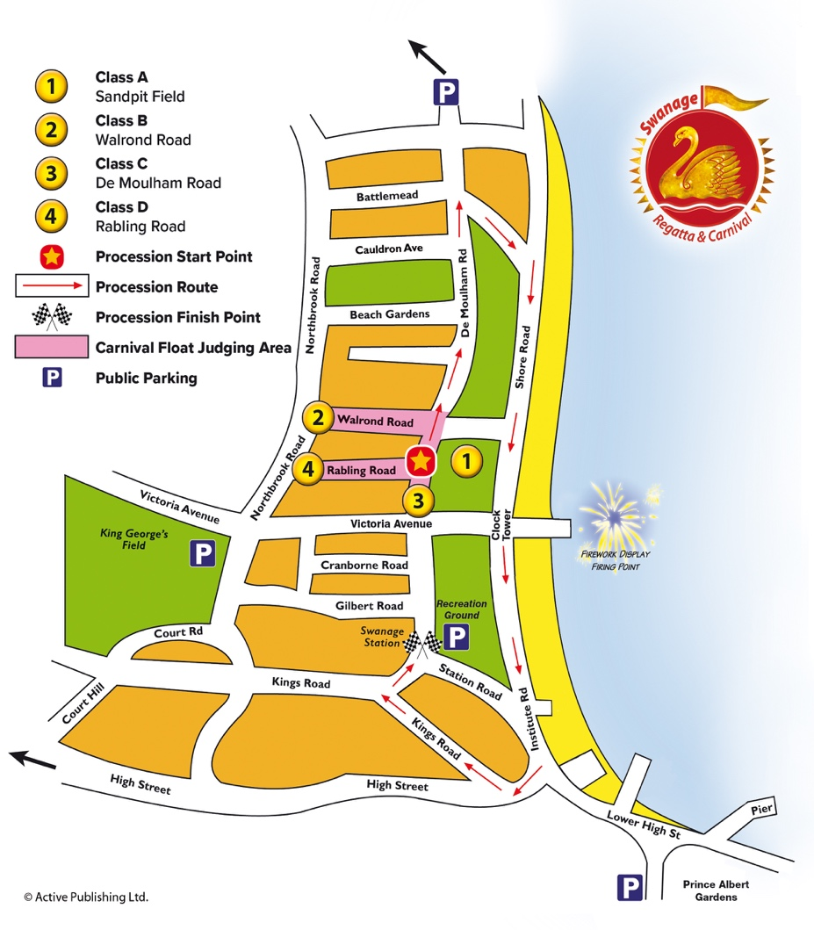
De Moulham Road – Clifton Road - Shore Road – Institute Road – High Street – Kings Road East - Kings Road West – Ending at the Railway Station

REGISTER:

Please remember to send your completed procession entry form to:
Procession, Unit 8, Jaden Business Park, Prospect Way, Swanage. BH19 1EJ or email – chair@swanagecarnival.com For Enquiries phone: 07792 368456

Thank you for entering one of the south’s most popular Carnival Processions.
We Appreciate it’s YOUR enthusiastic support which makes it all possible.

