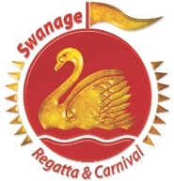
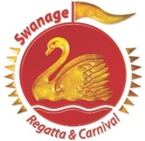
SWANAGE CARNIVAL
VINTAGE AND CLASSIC CAR SHOW
Friday 5th August 2022

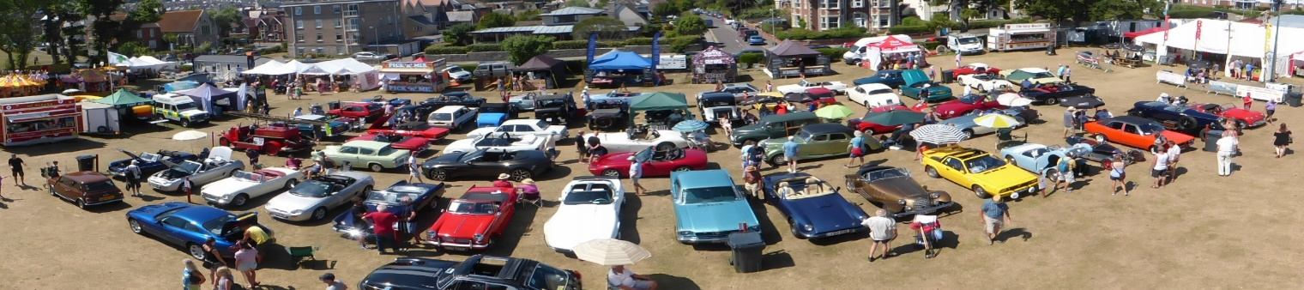
Draw prizes supported by local garages & service centres
Entry form 2022
Please complete in full in block capitals to arrive by 1st July 2022
(Restricted to 50 vehicles)
Name………………………………………………………………………. Tel No…………………………………………
Address …………………………………………………………………… Mobile……………………………………….
………………………………………………………………………………… Email ………………………………………...
………………………………………………………………………………… Post code…………………………………..
Make of vehicle……………………………………………………….. Model……………………………………….
Registration No………………………………………………………… Year………………………………………….
No entry fee required but if you would like to make a donation it would be gratefully received.
Conditions of entry – I agree to indemnify and hold members of Swanage Regatta & Carnival and Swanage Town Council and its employees free from any claims that have been caused by me or persons under my direction or by my vehicles or by my equipment. I understand my vehicle must have minimum third party insurance for the event and I agree to abide by the direction of the show stewards and the Health & Safety advice issued on the day

Vehicles to be in place by 10am restricted movement until 16.00.
Please supply oil drip tray

Signed……………………………………………………………………. Date…………………………………………...

Please return by post to: Jim Walker C/O Steve Curtis, 45, Cauldron Crescent, Swanage, BH19 1QL

Entries to be received by 1st July 2022
Follow us
www.swanagecarnival.com

